MCA SEM II AWT PRACTICAL
Assignment 1

Date: 03-03-2026

Q1. Design ASP.NET web page to demonstrate page life cycle.
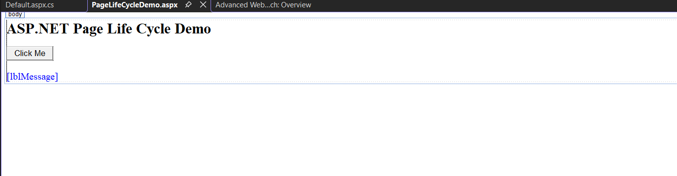
Output:
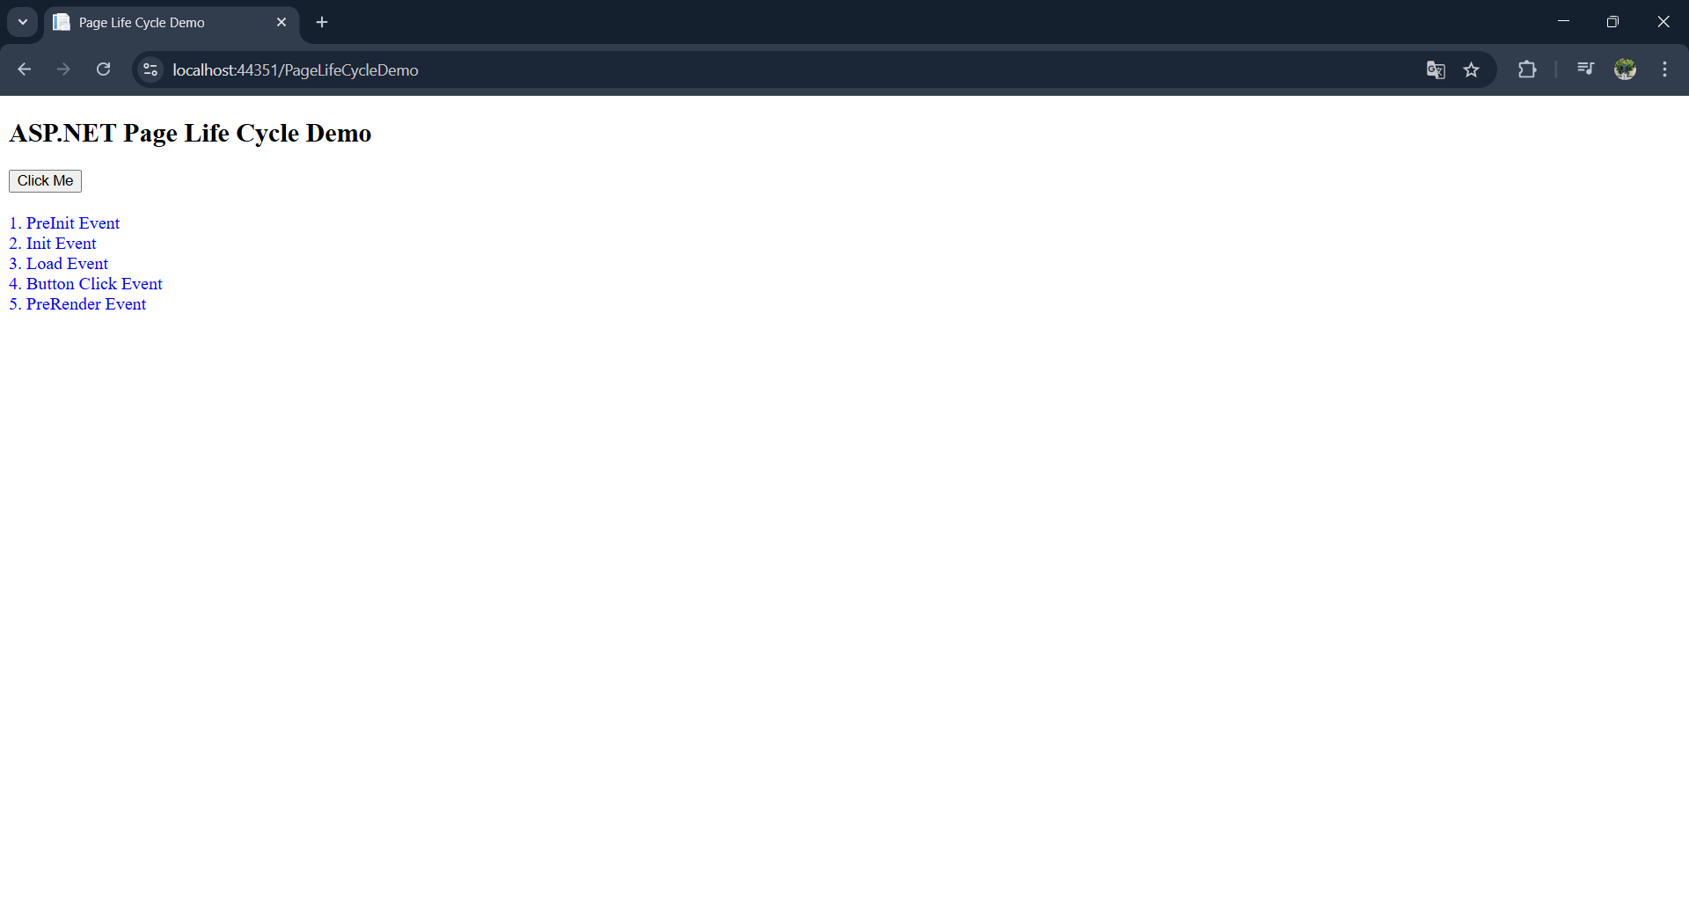

Q2. Design registration from using Web server controls
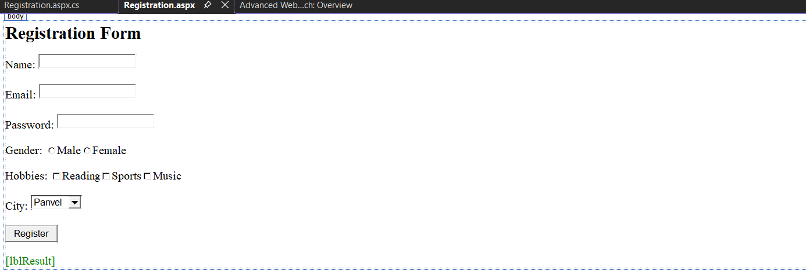
Output:
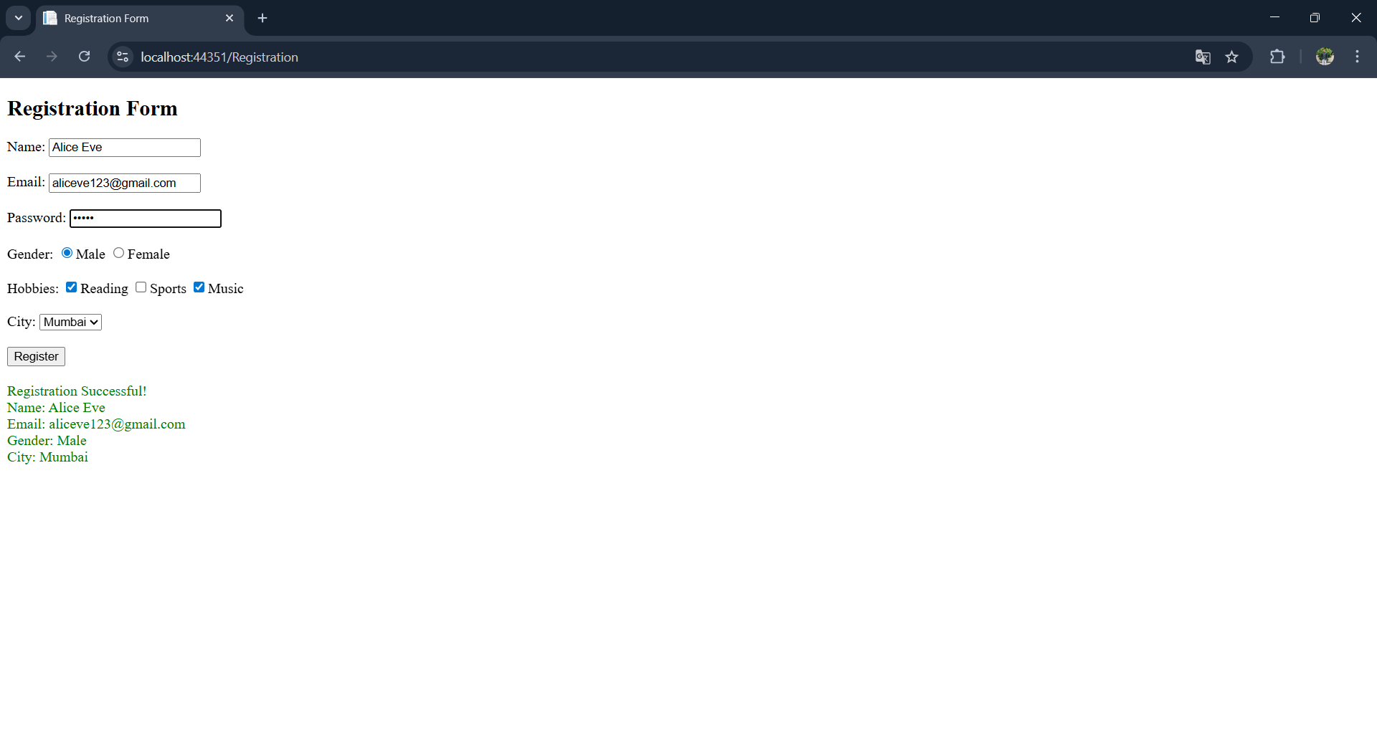

Q3. Create a simple calculator using server-side controls and operators in ASP.NET.
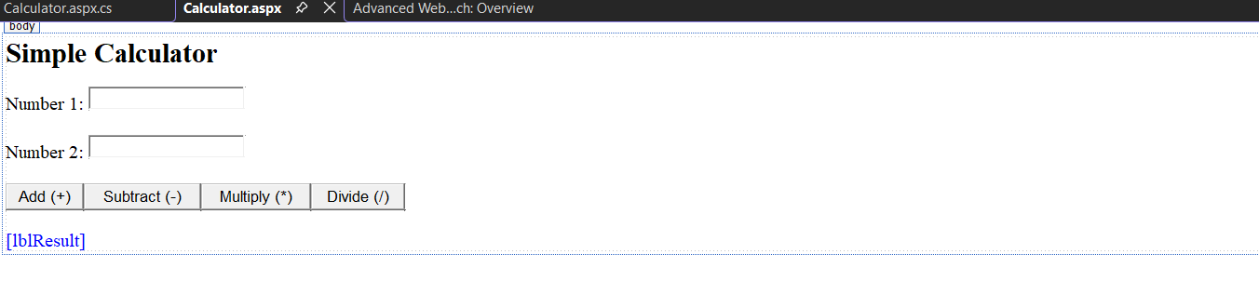
Output:
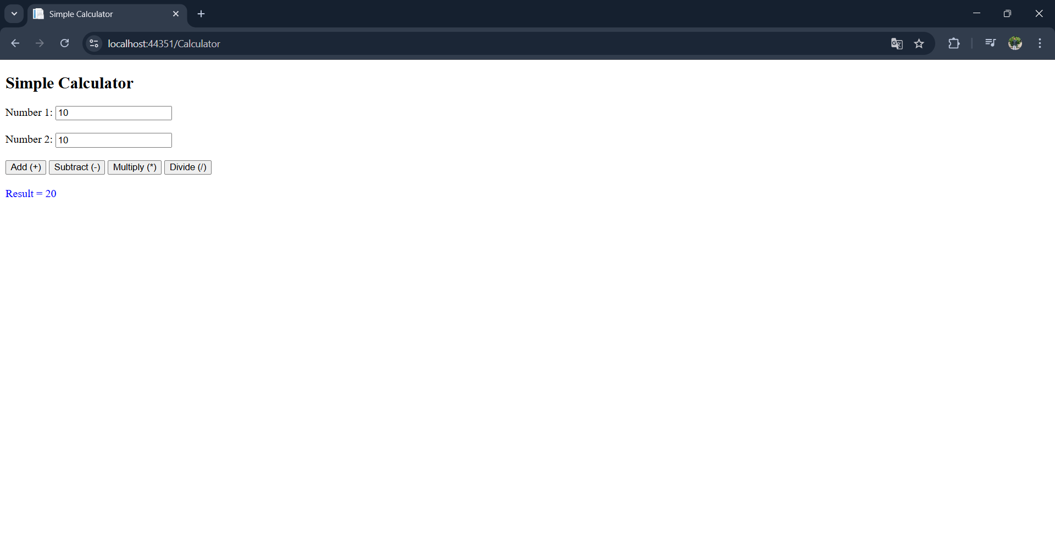

Q4. Design web for list the squares of given range of numbers in a list box.
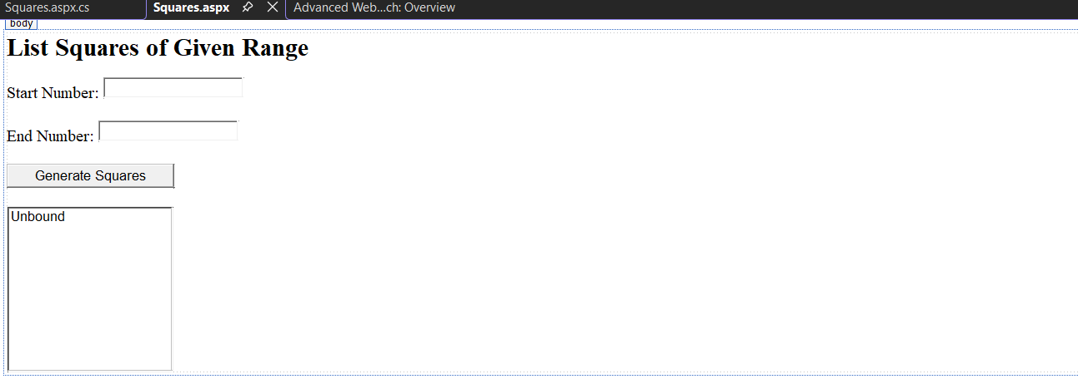
Output:
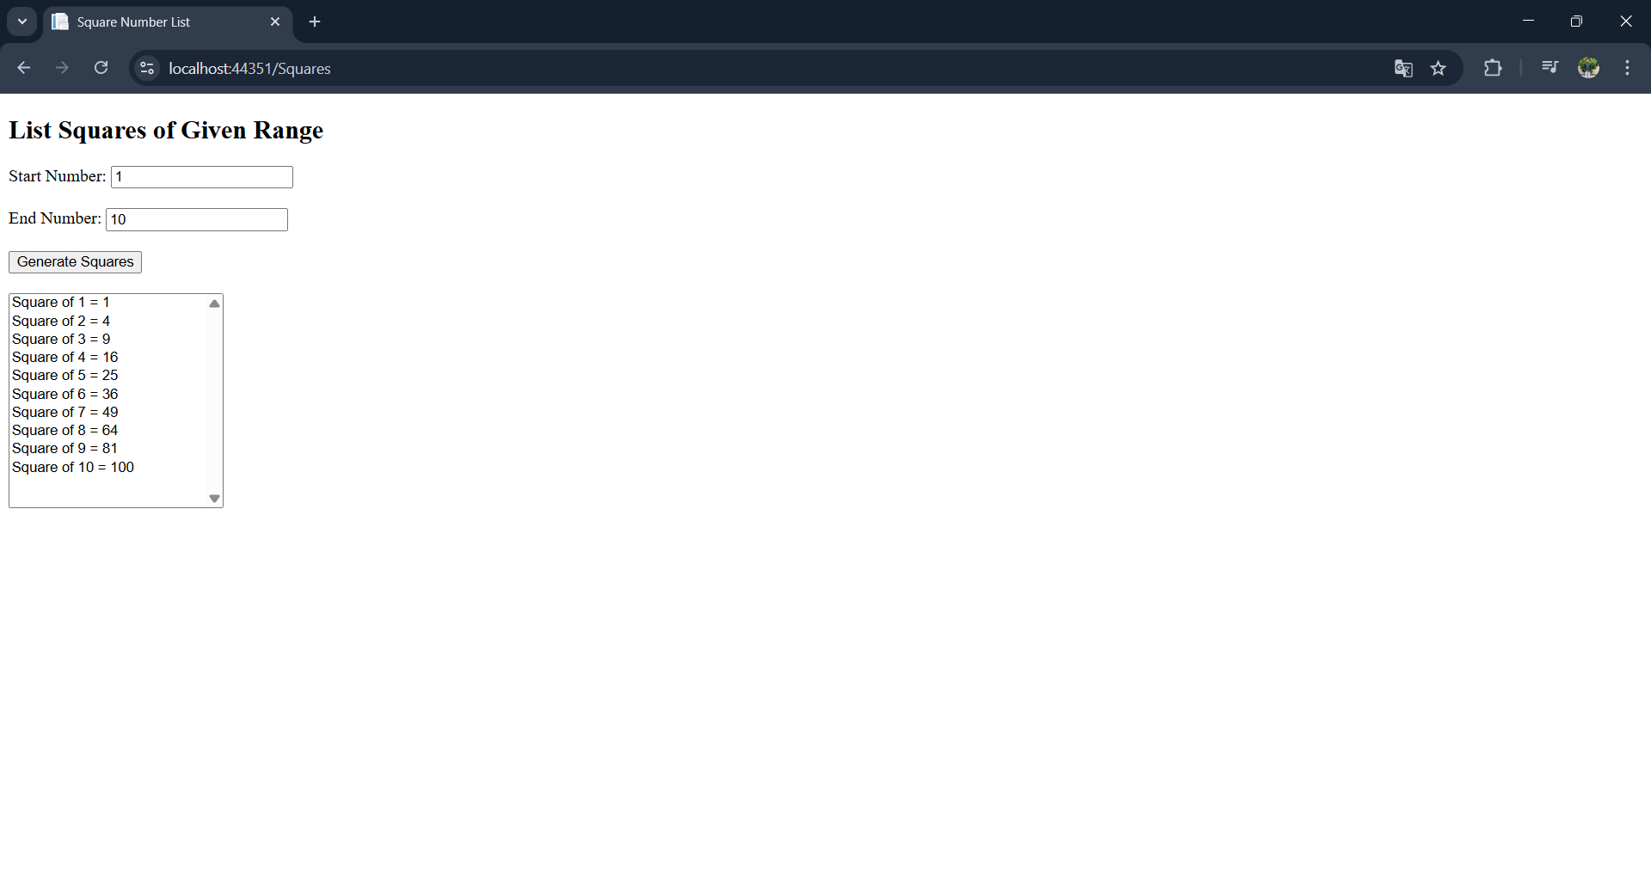

Q5. Implement a Cross Page Postback feature to pass data between two web pages.
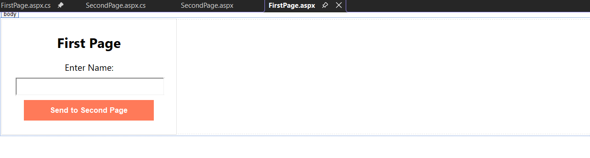
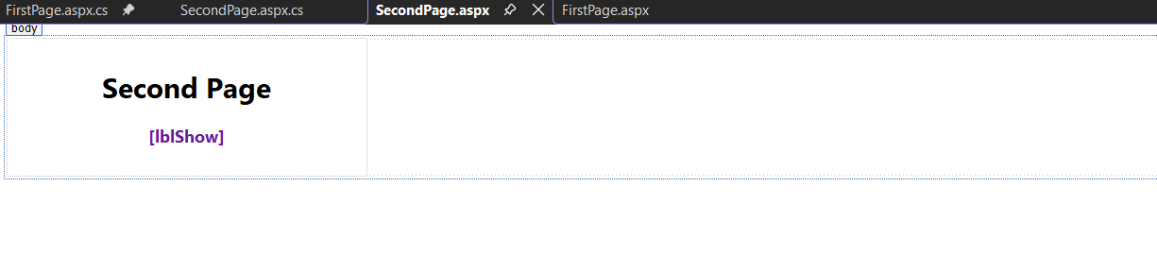
Output:
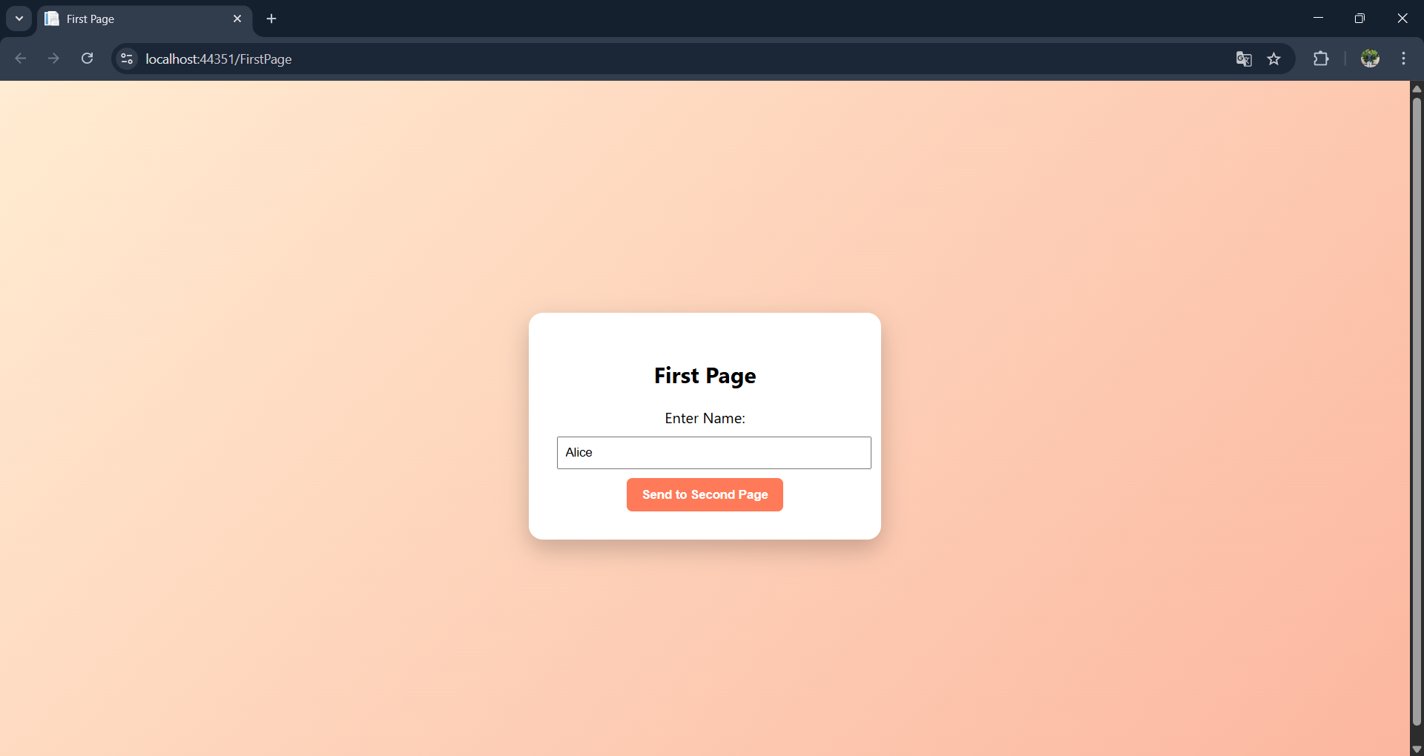
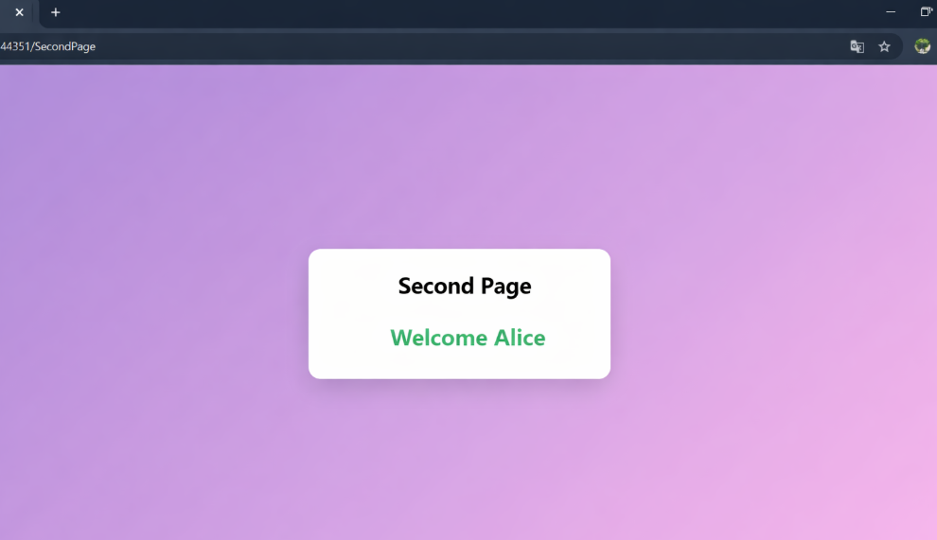

Q6. Develop a web application demonstrating AutoPostback using a dropdown list to select and display items.
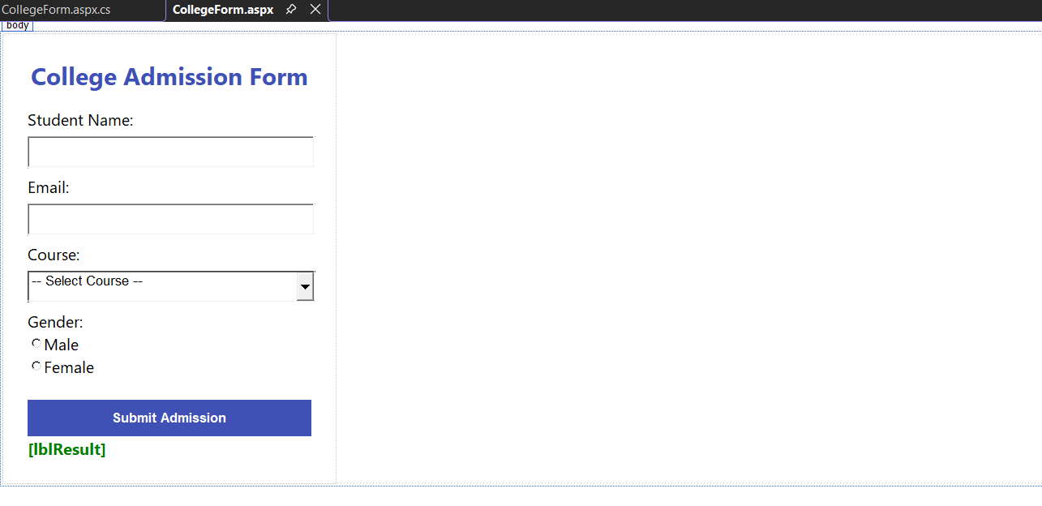
Output:
